New to RE?

Find the best support for the start of your career here!

New2RE programme September 2019

• Are you likely to be a newly qualified secondary RE teacher in September 2019?
• Are you keen to extend your repertoire of strategies for teaching RE?
• Would support with deepening subject knowledge be helpful as you teach six religions and non-religious worldviews?
• Would you value having an experienced RE teacher/leader as a personal mentor?

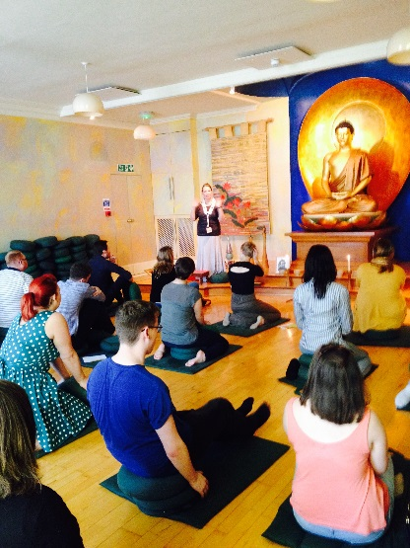
If so, you'll be pleased to hear about the New2RE programme from the National Association of Teachers of RE (NATRE). Now in its sixth year, the New2RE programme is currently supporting over 70 new teachers as they begin their careers. This is a fantastic opportunity for NQTs beginning their careers as RE specialists in September 2019 to be supported by RE experts and gain access to hundreds of quality-assured resources.
New2RE is designed to support RE teachers in the first three years of their teaching career. It aims to help develop subject knowledge and confidence as a teacher of RE. The programme is tailored to individual needs and is designed to complement and enhance the provision offered by schools.
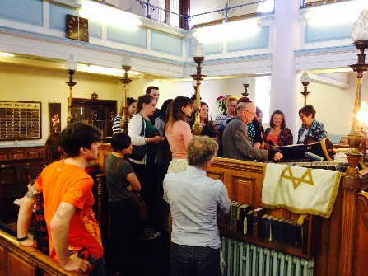
The programme is free to the teacher, subject to a contribution from the participating school, and permission from the head teacher/principal to attend the residential course.
We have 25 places to offer to NQTs on our three-year* early career development programme: New2RE.
*subject to continuing funding

We are able to provide this programme thanks to the generous support of:

As part of the New2RE programme you will:
1. complete a subject knowledge and skills audit to help you identify your professional development priorities in year one
2. meet a mentor – an experienced RE teacher/subject leader – to discuss these priorities, either face-to-face, via Skype or through email. Your mentor will help you choose from a number of options for activities to include in your Personal Professional Development Plan (PPDP) for the year. The plan will be flexible and can be modified if your needs or circumstances change
3. choose from a range of support on offer, including reading material, an online webinar, watching a video resource, participating in a Twitter chat or other activities to develop your skills and subject knowledge
4. agree your PPDP with the head of professional development in your school to ensure that the plan complements the school-based programme for your NQT year. Some schools have their own equivalent to a PPDP and the New2RE programme allows for other formats to be used
5. find that the programme helps you to build on your learning from your ITE year without creating a burden as you plan your lessons and carry out your other duties as a teacher
6. have regular contact with your mentor to discuss your progress with your PPDP and your responses to the different activities you have chosen to complete
7. complete a half termly web-log (blog) online to help your mentor monitor your progress. Your receipt of the benefits from the programme will be dependent on your completion of the blog. The project blog will help to build links between the 25 New2RE teachers and mentors
8. attend a New2RE 30-hour residential course in the third term of the programme. The course will be led by Deborah Weston from NATRE, with Lat Blaylock and Stephen Pett from the RE Today team. You will meet other RE specialists and have the opportunity to learn from their experience as well as to share your own. This is a funded part of the programme
9. continue to be supported by your mentor in years 2 and 3 of the programme. You will attend a free RE Today course as appropriate to your need

Benefits
• A place on this programme comes with a free NATRE membership, to help you to take your place in the RE community. This membership will provide you with a termly mailing including REtoday magazine, the British Journal of Religious Education and a secondary curriculum publication.
• You will have access to the NATRE membership area of the website with over 800 resources, the RE Today online subscriber area and access to NATRE-affiliated Local Groups.
• £100 off a NATRE/RE Today courses and conferences and £30 off additional courses
• One FREE webinar
•Personal Lifestyle Benefits
•15% off Articles of Faith resources
• In addition, you'll receive monthly benefits including exclusive offers and discounts on resources, free monthly downloadable resources written by RE advisers sent directly to your email inbox.
• You will become part of a wider community of RE teachers, both through your mentor and by participating in the courses and webinars.
• As well as gaining from the support, you will also be well-placed to participate in the national development of RE through NATRE, who are always looking for fresh ideas and energy to promote excellent RE teaching.
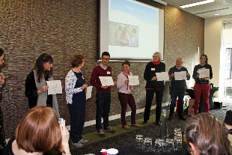

What to do:
• Talk to your head teacher/principal.
• Fill in the application form on the next page – your head teacher will need to sign to say that they support your place on the programme for three years, give permission for you to attend the residential course in June of each year you are part of the programme, and will make the £120 contribution to the programme each year, on the understanding that the programme is worth over £1,000.
• This is a three-year programme. If you move schools, you will be able to take it with you as long as your new school agrees.

Application form: New2RE programme September 2019–2022
Name of participating NQT
Home address of NQT, including post code
(this is where we will send your membership information and mailings)
NQT email address(es) School and home if possible
Name of school
School address (inc. post code)
School telephone number
Name and email address of teacher responsible for NQTs
Name of head teacher
Head teacher agreement  (Must be the Headteacher or principal) | I support the above-named NQT in their application for this programme.  The school will contribute £120 towards year 1 of the programme when invoiced in September 2019 and subsequently for years 2 and 3 in September 2020 and 2021. I will allow him/her to attend the residential course on a Friday & Saturday in June of each year.  Signed………………………………………………………………………………………………..  Name (Print)..……………………………………………………………………………………….

Please return completed forms to:
Deborah Weston, NATRE, 5–6 Imperial Court, 12 Sovereign Road, Birmingham B30 3FH
Or by email: deborah@retoday.org.uk and admin@natre.org.uk (please ensure you send to both)

HOW WE USE INFORMATION ABOUT YOU AND RECIPIENTS OF YOUR INFORMATION: We will use your information in performance of your contract with us and the provision of our services to you including our legitimate interests, for further details please view our full privacy policy and your rights at https://www.retoday.org.uk/your-data-rights You raise any queries by emailing dataprotection@retoday.org.uk

